Health History Form

The information requested bellow will assist me in providing you with a safe and effective treatment. Please notify me if there are any changes to your health status. Please note that all information bellow will be kept confidential unless allowed or required by law. Your written permission will be required to release any information.
________________________________________________________________________________________________________________________

Name:_______________________________________________ Date of Birth:_______________________________________________
Address:____________________________________________ City:_______________________ Postal Code:___________________
Occupation:_________________________________________ Daytime Phone #:__________________________________________
Alt. Phone #_________________________________________ E-Mail Address:____________________________________________
Reason for seeking Massage Therapy:____________________________________________________________________________
Family Physician:___________________________________ Address:_____________________________________________________
Phone #:_____________________________________________
Please Circle:
Do I have permission to contact your family physician? YES NO

Do I have permission to contact you using this e-mail address? YES NO
How did you hear about this clinic? REFFERAL INTERNET OTHER:_______________________________
(If Referred, by who:____________________________________________________)
Is this your first time receiving Registered Massage Therapy? YES NO
Please check all conditions that apply to you currently and/or previously:
Cardiovascular:  - High blood pressure  - Low blood pressure  - Chronic congestive heart failure  - Heart Attack  - Phlebitis/varicose veins  - Stroke/CVA  - Pacemaker or similar device  - Heart disease  Is there a family history of any above conditions?  YES NO | Infections:  - Hepatitis  - Skin conditions  - TB  - HIV  - Herpes  Respiratory:  - Chronic cough  - Shortness of breath  - Bronchitis  - Asthma  - Emphysema  Is there a family history of any above conditions?  YES NO |  | Head/Neck:  - History of head aches  - History of migraines  - Vision problems  - Vision loss  - Ear problems  - Hearing loss  Women:  - Pregnancy, Due:_____________________  - Gynecological conditions ___________________________  PLEASE TURN PAGE OVER ->
Soft Tissue/Joint Pain:  - Neck  - Upper back/shoulders  - Arms/hands  - Midback  - Lowback  - Hips/legs  - Knees/feet  - Other:_________________ | Other Conditions:  - Loss of sensation  Location:________________________  - Diabetes,  Onset:___________________________  - Allergies, type______________  Reaction:________________________  - Epilepsy  - Cancer  Type/location:__________________  - Arthritis___________________  Is there a family history of any above conditions?  YES NO |  | Gastrointestinal:  - Constipation  - Diarrhea  - Irritable Bowel Syndrome  - Other:_________________  Overall Health:  - Poor  - Average  - Good  - Excellent
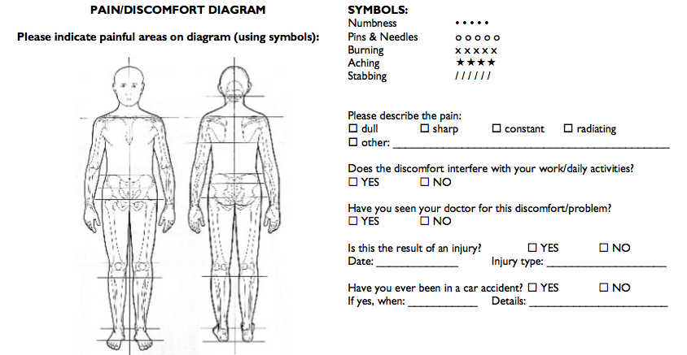
Current Medications:  ___________________________________________________________  ___________________________________________________________  ___________________________________________________________  Are you currently receiving treatment from another healthcare professional? YES NO  If yes, for what?_________________________________ |  | Past Surgeries/Injuries (Include Date):  ___________________________________________________________  ___________________________________________________________  ___________________________________________________________  Do you have any internal pins, wires, or artificial special equipment? YES NO  If yes, what?_________________________________

